

American International University-Bangladesh (AIUB)

**Department of Computer Science**

**Faculty of Science & Technology (FST)**

**Emergency helpline management**

A Software Engineering Project Submitted

By

|  |  |  |
| --- | --- | --- |
| **Semester: Summer 2021-2022** | | **Section: B** |
|  | Student Name | Student ID |
|  | **4. MAHIMA FARAH MOON** | 20-42352-1 |

**Submitted to:**

**FARZANA BENTE ALAM**

**Lecturer, Computer Science**

# 1. PROJECT PROPOSAL

## 1.1 Background to the Problem

In our daily life we face many problems and many unexpected situations. Some problems we can face by our own and but most of the problems we can't face alone. And for this Bangladesh Government launched emergency helpline numbers. So that general people can have emergency help i.e., medical service, rescue service, crime related service. But for many reasons we can't make call from everywhere or from every situation. Many people go unnerved as to what to do in an emergency. And because of this, problems get more worst. To solve this crisis moment, we are launching web-based system. As we are in age of advance technology, almost everyone has data connection in their device. So, people can access this system from anywhere and anytime. Moreover, by phone call it's hard to track the right location. But from this system we can track location of victim and can send emergency service in short time,

## 1.2 Solution to the Problem

To face unexpected crisis situation, we are making this web-based system. In this system we are going to provide three services. If anyone face health related illness, or accident for this he will choose medical helpline. For this we will provide an ambulance to the victim's location as soon as possible with two nurses. They will provide first aid. Then ambulance will drop to the preferable hospital. The victim will pay the ambulance fee. If anywhere happens fire related accident or any rescue related issue then user will choose fire service helpline. Then we will provide a fire service team for rescue mission. If anywhere happens any crime related issue, then we will contact with police and police will go to the victim's location as soon as possible. But if any user call for any helpline without any reason, then he/she will be fined for a good amount of money and police will handle this.

## 2. SOFTWARE DEVELOPMENT LIFE CYCLE

### **2.1 Process Model**

We have used ‘Waterfall’ model for our project development process. We used This process because we get some benefit. Waterfall Model is a sequential model that divides software development into pre-defined phases. Each phase must be completed before the next phase can begin with no overlap between the phases. Each phase is designed for performing specific activity during the SDLC phase. Advantages and disadvantages of Waterfall model:

|  |  |
| --- | --- |
| **Advantages** | **Dis-Advantages** |
| • Before the next phase of development, each | • Error can be fixed only during the phase |
| **Advantages** | **Dis-Advantages** |
| phase must be completed |  |

* Suited for smaller • It is not desirable projects where for complex project requirements are where requirement well defined changes frequently

|  |  |  |  |
| --- | --- | --- | --- |
| • | They should perform quality assurance test (Verification and Validation) before completing each stage | • | Testing period comes quite late in the developmental process |

* Elaborate documentation is • Documentation

occupies a lot of done at every phase time of developers

of the software’s

and testers development cycle

|  |  |  |  |
| --- | --- | --- | --- |
| • | Project is completely dependent on project team with minimum client intervention | • | Clients valuable feedback cannot be included with ongoing development phase |

* Small changes or
* Any changes in

errors that arise in software is made the completed during the process software may cause of the development a lot of problems

**Waterfall model is better than other models:**

Here’s an in-depth look at what the Waterfall methodology does best.

## 1. Uses clear structure

When compared with other methodologies, Waterfall focuses most on a clear, defined set of steps. Its structure is simple—each project goes through these steps:

* Requirement gathering and documentation
* System design
* Implementation
* Testing
* Delivery/deployment
* Maintenance

Teams must complete an entire step before moving onto the next one, so if there are roadblocks to completion, they’re brought to light right away. Half-finished projects are less likely to get pushed aside, leaving teams with a more complete, polished project in the end.

In addition to being clear, the progression of Waterfall is intuitive. Unlike Six Sigma or Scrum, Waterfall does not require certifications or specific training for project managers or employees. If you visually outline the process at the beginning using Lucidchart and explain the methodology, team members will be able to jump into the Waterfall system without a steep learning curve slowing their progress.

## 2. Determines the end goal early

One of the defining steps of Waterfall is committing to an end product, goal, or deliverable at the beginning, and teams should avoid deviating from that commitment. For small projects where goals are clear, this step makes your team aware of the overall goal from the beginning, with less potential for getting lost in the details as the project moves forward.

Unlike Scrum, which divides projects up into individual sprints, Waterfall keeps the focus on the end goal at all times. If your team has a concrete goal with a clear end date, Waterfall will eliminate the risk of getting bogged down as you work toward that goal.

## 3. Transfers information well

Waterfall’s approach is highly methodical, so it should come as no surprise that the methodology emphasizes a clean transfer of information at each step. When applied in a software setting, every new step involves a new group of people, and though that might not be the case at your company, you still should aim to document information throughout a project’s lifecycle. Whether you’re passing projects off at each step or experience unexpected personnel changes, Waterfall prioritizes accessible information so new additions to the team can get up to speed quickly if needed.

You can maximize your benefits from this characteristic of Waterfall by staying organized with the right process. Use Lucidchart (it’s free to sign up!) to document processes so each team member knows what has already been done on a project when it gets to them.

**2.2 Project Role Identification and Responsibilities**

1. **Requirement’s analyst**:

In this phase, the requirements of the proposed system are collected by analyzing the needs of the user(s).

1. **System Designer**:

System engineers analyze and understand the business of the proposed system by studying the user requirements document. They figure out possibilities and techniques by which the user requirements can be implemented. If any of the requirements are not feasible, the user is informed of the issue. A resolution is found and the user requirement document is edited accordingly.

1. **Architecture Designer**:

The baseline in selecting the architecture is that it should realize all which typically consists of the list of modules, brief functionality of each module, their interface relationships, dependencies, database tables, architecture diagrams, technology details etc.

1. **Module Designer**:

The designed system is broken up in to smaller units or modules and each of them is explained so that the programmer can start coding directly. The low-level design document or program specifications will contain a detailed functional logic of the module, in pseudocode - database tables, with all elements, including their type and size - all interface details with complete API references- all dependency issues- error message listings- complete input and outputs for a module.

**User Functional Requirements:**

* 1. **Sign-up:**
  + User will sign-up/register to our website by using their email and phone number.
  + User will provide unique username and password and system will save to database.
  + System will check if the username is already taken or not. If yes then user should try another username.
  + While sign-up user should provide their personal information. Such as their address, NID / passport/birth certificate.
  + System will verify information and then it will save to database. **Priority Level:** High

**Precondition:** user have valid NID/passport/birth certificate and email/phone number.

Cross-references: 4.1, 7.2 (example)

* 1. **Login:**
  + The website shall allow users to login with their given username and password. User can see password by pressing eye button.
  + The login credentials (username and password) will be verified with database records.
  + If the login successful the home page of the user account will be displayed.
  + If the username and/or password has been inserted wrong, the random verification code will be generated and sent to the user’s email address by the system to retry login.
  + If the number of login attempt exceed its limit (3 times), the system will ask to reset the password and will send a text massage to user contact number with login details. And will verify login attempt.
  + If user forget password or username then user can reset password/username through given email or phone number. **Priority Level:** High

**Precondition:** user have valid username and password.

* 1. **Profile:**

• User can edit his profile or can update contact number and payment options.

* 1. **Request for Service:**
  + After successful login user will see homepage. There will be a service list. In the top corner there will be a live update, service history and feedback button.
  + User will choose their preferable service from the list. Then a new page will open regarding to the chosen service. In this page user will provide details of the report. For the user system will automatically locate his/her location and the service will be provided to the location.

1. **History:**

• User can see his previous report details and can give feedback or suggestion.

1. **Notifications:**

• User will be notified if there any update related his report.

1. **Payment:**

• User can pay by using any back account or any mobile banking system.

**Admin Functional Requirement:**

**1. Login:**

* The website shall allow admins to login with their given username and password. Admin can see password by pressing eye button.
* The login credentials (username and password) will be verified with database records.
* If the login successful the home page of the ad account will be displayed.
* If user forget password or username then user can reset password/username through given email or phone number. **Priority Level:** High

**Precondition:** Admin have valid username and password.

1. **Pending Reports Check:** 
   * Admin will check the report list submitted by user as soon as user submit their reports and take action regarding to the reports.
2. **Provide Services:** 
   * After checking the reports admin will contact with ambulance / police station/ fire service and will send the location of user to provide service in shortest time.

**Non-Functional Requirements:**

**Maintainability:** We keep updated our apps for avoiding any kind of defects and for prevent unexpected conditions. We have a controller system to connect with the people who needs help

**Open source:** Open source is source code that is made freely available for possible modification and redistribution. In our app, anyone can register the app anytime.

**Privacy:** When something is private to a person, it usually means that something is inherently special or sensitive to them. The domain of privacy partially overlaps with security, which can include the concepts of appropriate use and protection of information. In our app, we made everything confidentially. Only the patient and controller can know about the history of patient.

**Response time:** response time is the time a system or functional unit takes to react to a given input. In our app, we make sure that we can response in time. In our app, when anyone register and seek for help, controller immediately respond to look the matter.

**Transparency**: To avoid spam cases, we made the system of charge. Victim needs to pay a certain amount to get our services and it is transparent.

**History:** If anyone register, first apps check that victim have any history or not. Like victim took our services before or not. patients’ history like he/she has diabetes or not etc. like this, we have a system to check the history.

**Accessibility:** Accessibility is the design of products, devices, services, vehicles, or environments so as to be usable by people with disabilities. The concept of accessible design and practice of accessible development ensures both "direct access" and "indirect access" meaning compatibility with a person's assistive technology

**Adaptability:** Adaptability is a feature of a system or of a process. In ecology, adaptability has been described as the ability to cope with unexpected disturbances in the environment. With respect to business and manufacturing systems and processes, adaptability has come to be seen increasingly as an important factor for their efficiency and economic success. In contrast, adaptability and efficiency are held to be in opposition to each other in biological and ecological systems, requiring a trade-off, since both are important factors in the success of such systems. To determine the adaptability of a process or a system, it should be validated concerning some criteria.

**Availability**: The degree to which a system, subsystem or equipment is in a specified operable and committable state at the start of a mission, when the mission is called for at an unknown. The probability that an item will operate satisfactorily at a given point in time when used under stated conditions in an ideal support environment.

**Backup**: In information technology, a backup, or data backup is a copy of computer data taken and stored elsewhere so that it may be used to restore the original after a data loss event. The verb form, referring to the process of doing so, is "back up", whereas the noun and adjective form is "backup". Backups can be used to recover data after its loss from data deletion or corruption, or to recover data from an earlier time. Backups provide a simple form of disaster recovery; however not all backup systems are able to reconstitute a computer system or other complex configuration such as a computer cluster, active directory server, or database server.

**Compliance:** compliance describes the goal that organizations aspire to achieve in their efforts to ensure that they are aware of and take steps to comply with relevant laws, policies, and regulations. Due to the increasing number of regulations and need for operational transparency, organizations are increasingly adopting the use of consolidated and harmonized sets of compliance controls. This approach is used to ensure that all necessary governance requirements can be met without the unnecessary duplication of effort and activity from resources.

**Deployment:** Software deployment is all of the activities that make a software system available for use. The general deployment process consists of several interrelated activities with possible transitions between them. These activities can occur at the producer side or at the consumer side or both. Because every software system is unique, the precise processes or procedures within each activity can hardly be defined. Therefore, "deployment" should be interpreted as a general process that has to be customized according to specific requirements or characteristics

**Use Case Diagram**

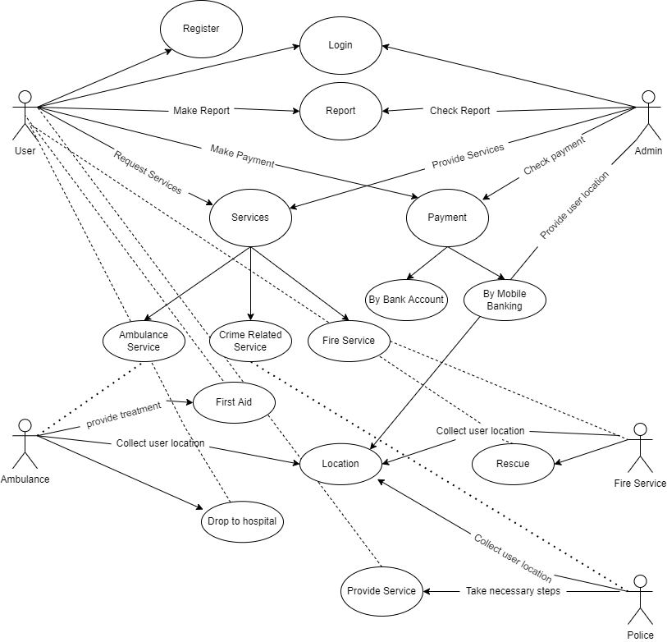

**Activity Diagram**

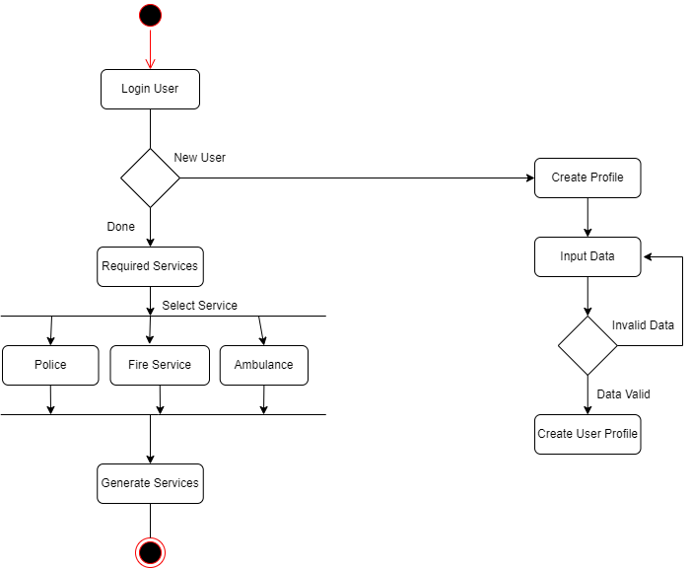

**Sequence**

**Diagram**

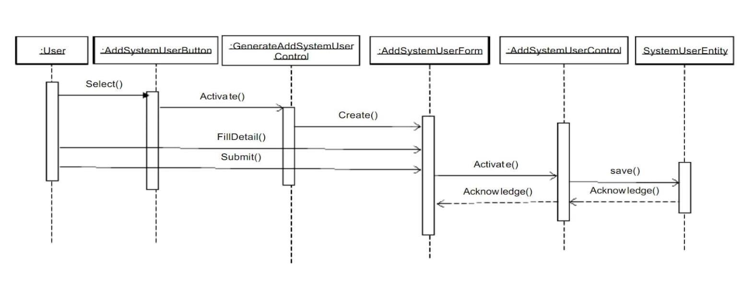

**ER-Diagram:**

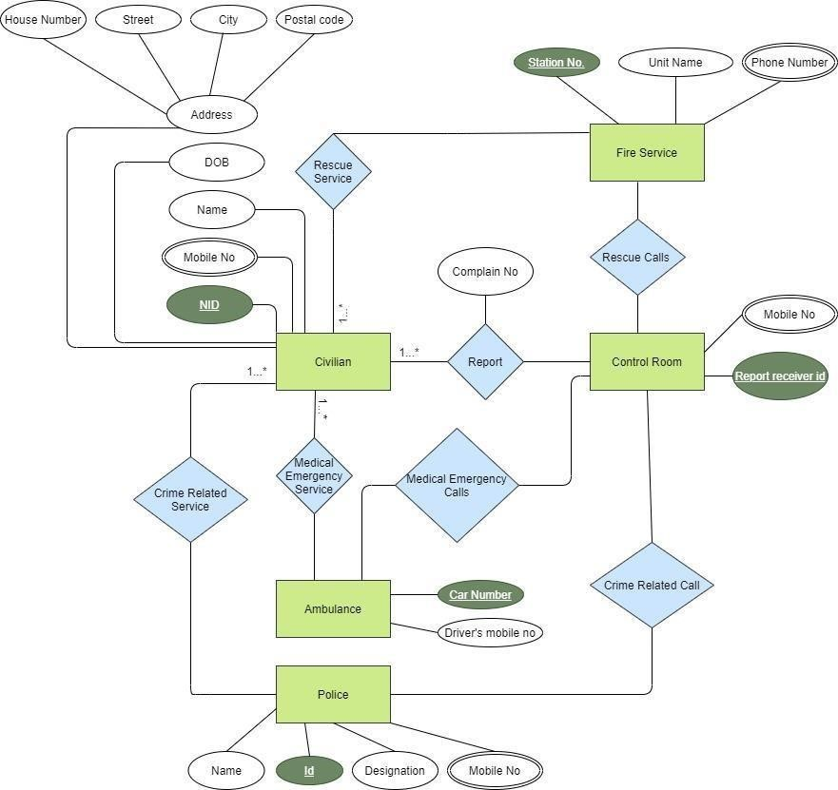

|  |  |  |  |  |  |
| --- | --- | --- | --- | --- | --- |
| Project Name: | | | Test Designed by: | | |
| Test Case ID:FR_l | | | Test Designed date: | | |
| Test Priority (Low, Medium, High):Medium | | | Test Executed by: | | |
| Module Name:Login Session | | | Test Execution date: | | |
| Test Title: verify login with valid usemame and password | | | | | |
| Description:Test website login page | | | | | |
| Precondition (If any): User must have valid username and password | | | | | |
| Test Steps | Test Data | Expected Results | | Actual Results | Status (Pass/Fail) |
| 1. Go to the website 2. Enter usename 3. Enter password 4. Click submit | Username:  **Saadman**  Password:1234 | User should login into the application | | As expected, | Pass |
| Post Condition:User is validated with database and successfully login to account. The account session details are logged in the database. | | | | | |

|  |  |  |  |  |  |
| --- | --- | --- | --- | --- | --- |
| Project Name: | | | Test Designed by:Saadman Saqib | | |
| Test Case ID:FR_l | | | Test Designed date: © MMH | | |
| Test Priority (Low, Medium, High):Medium | | | Test Executed by:Saadman | | |
| Module Name:Registation Session | | | Test Execution date: | | |
| Test Title: verify login with valid usemame and password | | | | | |
| Description:Test website login page | | | | | |
| Precondition (If any): User must have valid username and password | | | | | |
| Test Steps | Test Data | Expected Results | | Act ual Res  ults | Status (Pass/F  ail) |
| 1. Go to the website 2. Enter usename 3. Full Name 4. Last Name 5. Phone Number 6. Date of Birth 7. Enter password 8. Click submit | Username:  **Saadman72**  Full Name :  Saadman  Last Name:  Saqib  Phone Number:  **0171456790**  Date of Birth  **15/8/2000**  Password:1234 | User should  register into the application | | As expected, | Pass |
| Post Condition:User is validated with database and successfully register to account. The account session details are logged in the database. | | | | | |

|  |  |  |  |  |  |
| --- | --- | --- | --- | --- | --- |
| Project Name: | | | Test Designed by:Saadman | | |
| Test Case ID:FR_l | | | Test Designed date: | | |
| Test Priority (Low, Medium, High):Medium | | | Test Executed by:Saadman | | |
| Module Name:Hire Fire service | | | Test Execution date: | | |
| Test Title: Fire emergency helpline | | | | | |
| Description:Test fire service | | | | | |
| Precondition (If any): User must have valid username and password | | | | | |
| Test Steps | Test Data | Expected Results | | Act ual Res  ults | Status (Pass/F  ail) |
| 1. Go to the website 2. Login 3. Select fire service 4. Give details of your   situation     1. Click submit | Username:  **Saadman**  Password:1  234  I need fire service.. Here gas silinder had blasted .full floor of fire..we need fire service | User should login into the application      Fire serive will be sent user location | | As expected, | Pass |
| Post Condition:User is valas soon as idated with database and successfully login to account. The account session details are logged in the database.Fire service sent successfully | | | | | |

|  |  |  |  |  |  |
| --- | --- | --- | --- | --- | --- |
| Project Name: Emergency helpline management | | | Test Designed by: Badhon | | |
| Test Case ID:FR_2 | | | Test Designed date: 20/07/2022 | | |
| Test Priority (Low, Medium, High): Medium | | | Test Executed by: Badhon | | |
| Module Name: Crime Related Service | | | Test Execution date: 20/07/2022 | | |
| Test Title: Make a crime related report | | | | | |
| Description: Test Rescue Service | | | | | |
| Precondition (If any): User must have valid account and data connection. | | | | | |
| Test Steps | Test Data | Expected Results | | Ac tua  l | Status  (Pass/Fail) |
| 1. Go to the website 2. Login 3. Press service list button 4. Select Rescue Service 5. Give details of your situation 6. Press report button | Some boys  are teasing a girl near kuratoli. | Police will be reach to the user location and will take | | AsRe  expected, | Pass |
| Post condition: police reached to the victim’s location in a very short time and took necessary steps. | | | | | |

|  |  |  |  |  |  |
| --- | --- | --- | --- | --- | --- |
| Project Name: Emergency helpline management | | | Test Designed by: Badhon | | |
| Test Case ID:FR_2 | | | Test Designed date: 20/07/2022 | | |
| Test Priority (Low, Medium, High): Medium | | | Test Executed by: Badhon | | |
| Module Name: Hire Ambulance | | | Test Execution date: 20/07/2022 | | |
| Test Title: Medical Emergency Helpline | | | | | |
| Description: Test Medical Service | | | | | |
| Precondition (If any): User must have valid account and data connection. | | | | | |
| Test Steps | Test Data | Expected Results | | Act ual  Res | Status  (Pass/Fail) |
| 1. Go to the website 2. Login 3. Press service list button 4. Select Medical Service 5. Give details of your situation 6. Press report button | I need an ambulance to my address for the nearest heart surgery hospital as soon as possible | Ambulance will be sent to the user’s location | | As expected, | Pass |
| Post condition: ambulance was sent and provided service to user as expected. | | | | | |

|  |  |  |  |  |  |
| --- | --- | --- | --- | --- | --- |
| Project Name: Emergency helpline management | | | Test Designed by: Badhon | | |
| Test Case ID:FR_2 | | | Test Designed date: 20/07/2022 | | |
| Test Priority (Low, Medium, High): Medium | | | Test Executed by: Badhon | | |
| Module Name: Service History | | | Test Execution date: 20/07/2022 | | |
| Test Title: List of service taken | | | | | |
| Description: Test Service history | | | | | |
| Precondition: User must have valid account and data connection. | | | | | |
| Test Steps | Test Data | Expected Results | | Act ual  Res | Status  (Pass/Fail) |
| 1. Go to the website 2. Login 3. Press history button 4. Press anyone of   the list to see the details | Medical Service  (Ambulance  reached to  Dhaka  Medical), Cost 1140tk  Date:  20/072022 | History list will be shown and by pressing any service of the list details of the service history will be shown. | | As expected, | Pass |
| Post condition: History list came up and by pressing any service history the details also shown. | | | | | |

|  |  |  |  |  |  |
| --- | --- | --- | --- | --- | --- |
| Project Name: Emergency helpline management | | | Test Designed by: Fahad | | |
| Test Case ID:FR_l | | | Test Designed date: 20-07-2022 | | |
| Test Priority (Low, Medium, High):Medium | | | Test Executed by: Fahad | | |
| Module Name:Forget password | | | Test Execution date:21-07-2022 | | |
| Test Title: Login session | | | | | |
| Description:Test website login page | | | | | |
| Precondition (If any): User must have valid username | | | | | |
| Test Steps | Test Data | Expected Results | | Actual Results | Status (Pass/Fail) |
| 1. Go to the website 2. Click forget password 3. Enter username 4. Click submit | Username:  Fahad  New  Password:1234 | User should be create new password | | As expected, | Pass |
| Post Condition:User is validated with database and successfully change password . The account session change password are logged in the database. | | | | | |

|  |  |  |  |  |  |
| --- | --- | --- | --- | --- | --- |
| Project Name: Emergency helpline management | | | Test Designed by: Fahad | | |
| Test Case ID:FR_l | | | Test Designed date: 20-07-2022 | | |
| Test Priority (Low, Medium, High):Medium | | | Test Executed by: Fahad | | |
| Module Name: Service list | | | Test Execution date:21-07-2022 | | |
| Test Title: home page session | | | | | |
| Description: Test main page service list | | | | | |
| Precondition (If any): User must be login website | | | | | |
| Test Steps | Test Data | Expected Results | | Actual Results | Status (Pass/Fail) |
| 1. Go to the website 2. Go to home page 3. Click any service | 1. Police 2. Ambulanc   e   1. Fire service | Service list will be shown | | As expected | pass |
| Post Condition: Service list has been shown | | | | | |

|  |  |  |  |  |  |
| --- | --- | --- | --- | --- | --- |
| Project Name: Emergency helpline management | | | Test Designed by: Fahad | | |
| Test Case ID:FR_l | | | Test Designed date:20-07-2022 | | |
| Test Priority (Low, Medium, High):Medium | | | Test Executed by: Fahad | | |
| Module Name: Payment | | | Test Execution date: 21-07-2022 | | |
| Test Title: payment session | | |  | | |
| Description: Test payment method page | | |  | | |
| Precondition (If any): User must have select valid payment method | | |  | | |
| Test Steps | Test Data | Expected Results |  | Actual Results | Status (Pass/Fail) |
| 1. Go to the website 2. Click payment 3. Select payment method 4. Confirm | User make payment two system bkash or visa card | Payment will be successful |  | As expected, | Pass |
| Post Condition: Payment Successful | | |  | | |

|  |  |  |  |  |  |
| --- | --- | --- | --- | --- | --- |
| Project Name: Emergency Helpline | | | Test Designed by: KAZI ISTIAK AHAMMED | | |
| Test Case ID: 3 | | | Test Designed date: 24-07-2022 | | |
| Test Priority: High | | | Test Executed by: | | |
| Module Name: System Integrity | | | Test Execution date: | | |
| Test Title: Test Integrity of the application | | | | | |
| Description: Test to see if the software’s integrity is working properly or not | | | | | |
| Precondition (If any): N/A | | | | | |
| Test Steps | Test Data | Expected Results | | Actual Results | Status (Pass/Fail) |
| 1. Go to the app 2. Select user type 3. Click forgot password 4. Enter phone number or email address 5. Press next button 6. Enter the received verification code 7. Insert new password and confirm | Phone number: 017xxxxxxx. Or Email address:  user123@gmail.com Or phone: 01xxxxx  Confirmation code: 903456 | A verification code will be sent to the user phone number  or email address for  validating the valid  user and setup the new password | | As expected, | Pass |
| Post Condition: A valid new password will be stored in the database. | | | | | |

|  |  |  |  |  |  |
| --- | --- | --- | --- | --- | --- |
| Project Name: Emergency Helpline | | | Test Designed by: KAZI ISTIAK AHAMMED | | |
| Test Case ID: 4 | | | Test Designed date: 24-07-2022 | | |
| Test Priority: Medium | | | Test Executed by: | | |
| Module Name: System Flexibility | | | Test Execution date: | | |
| Test Title: Test flexibility of the software | | | | | |
| Description: Test that the software's flexibility works in the shortest time possible or not | | | | | |
| Precondition (If any): N/A | | | | | |
| Test Steps | Test Data | Expected Results | | Actual Results | Status  (Pass/Fail) |
| 1. Enter as developer 2. Enter Service Category List 3. Select Service Category 4. Select specific service 5. Combine another service with that service using Edit Service Title option 6. Update service price   7. Confirm update. | Select service and edit the service title, update service price | Edit service name and update the service price successful | | As expected, | Pass |
| Post Condition: New edited service name and updated price will be updated in the database | | | | | |

Log-in

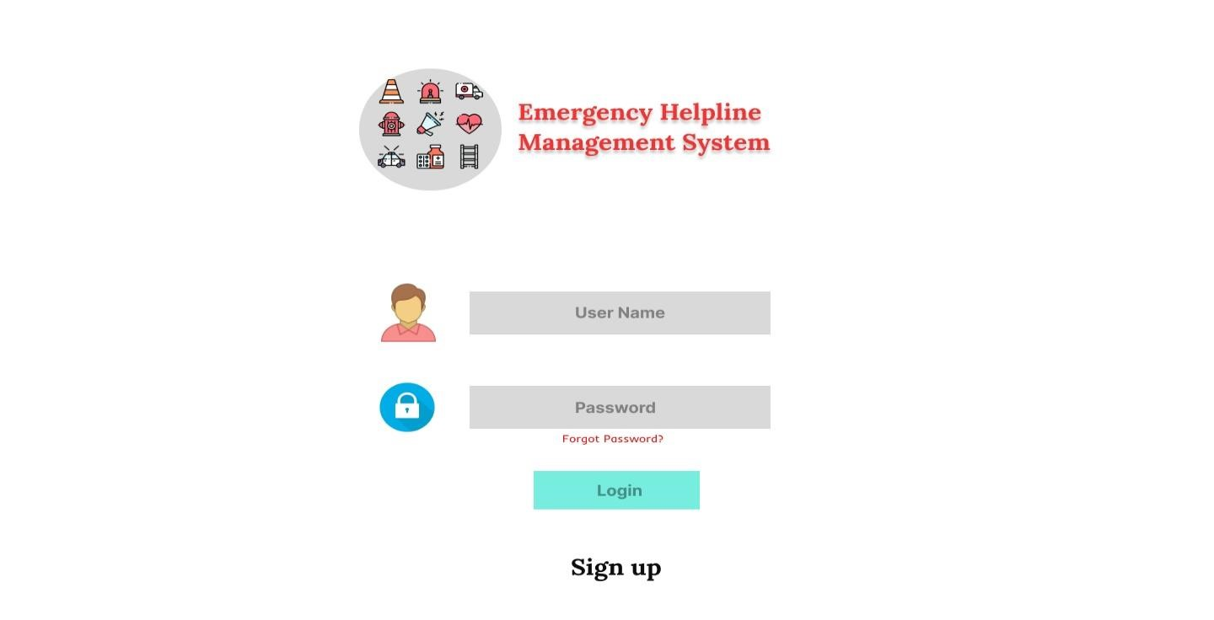

## Registration

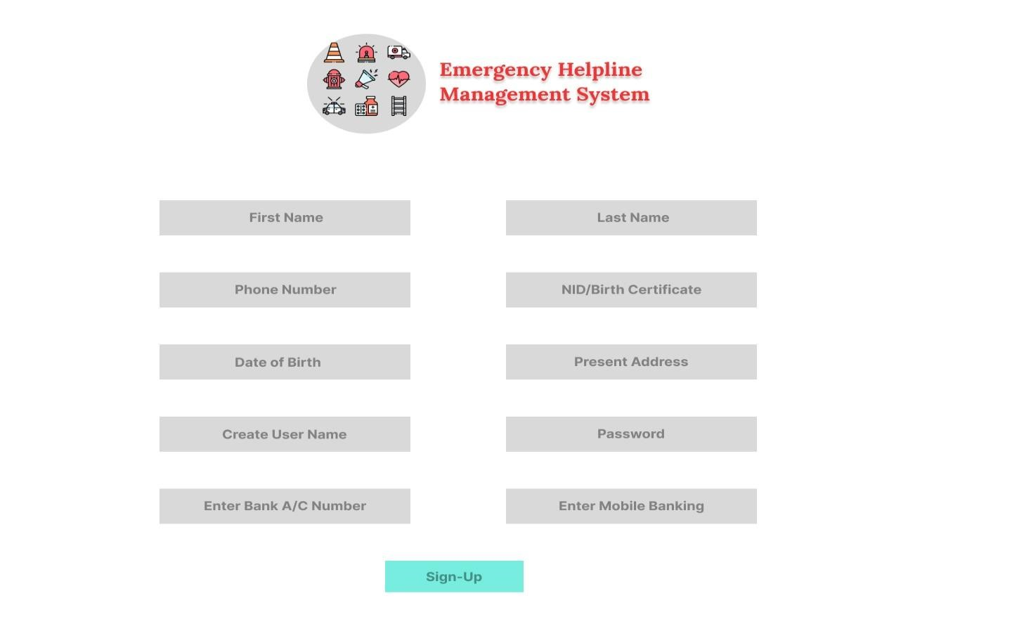

## Service List

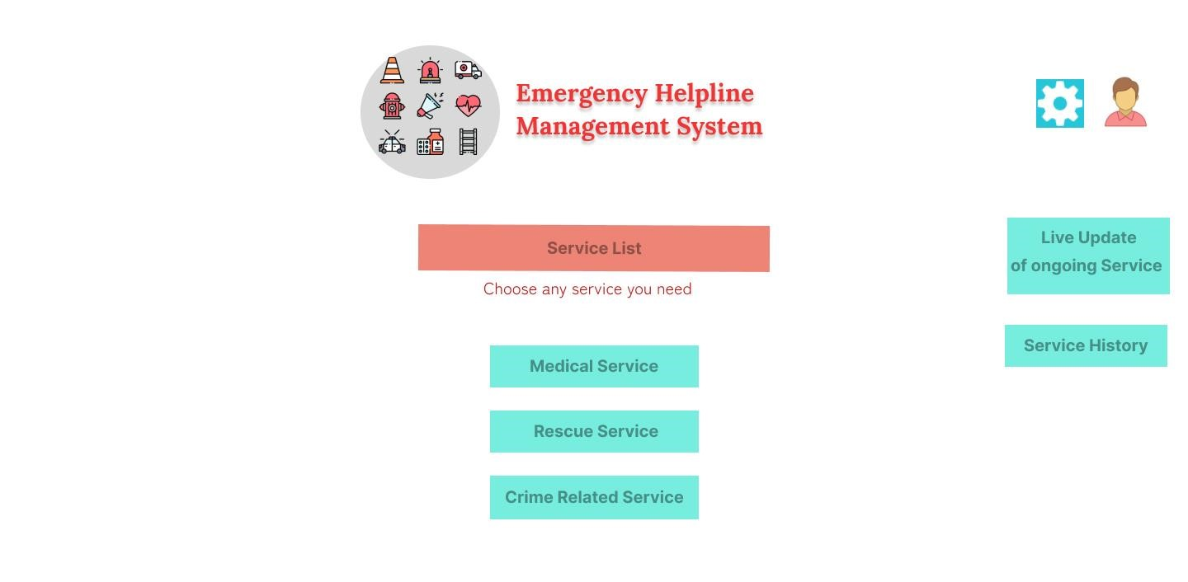

**Crime Related Service**

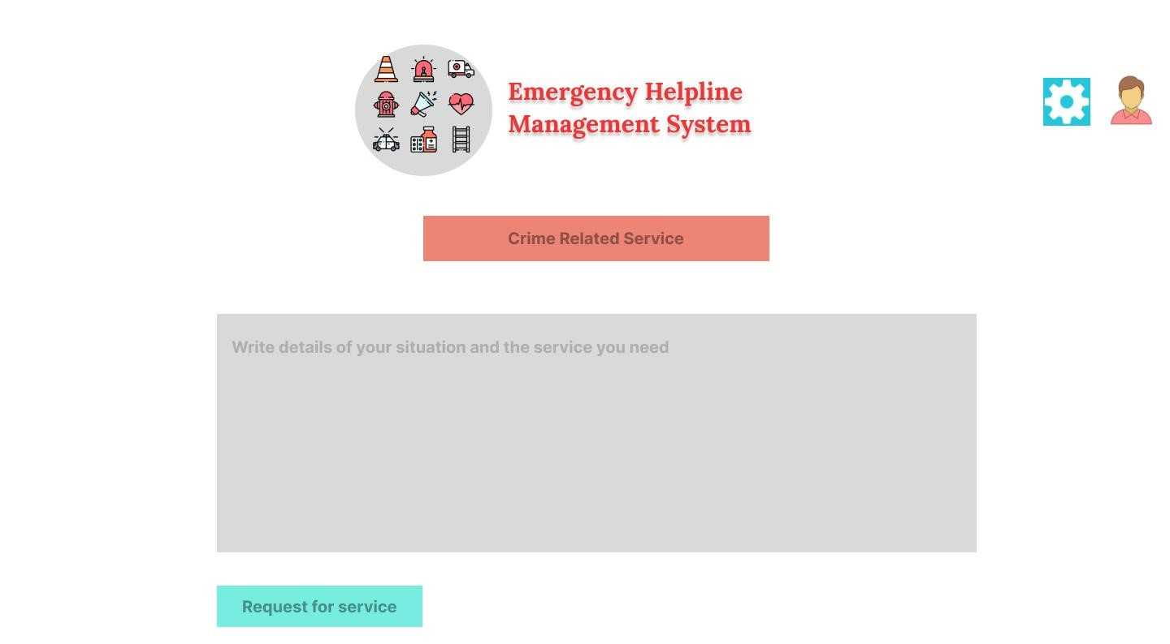

## Medical Services

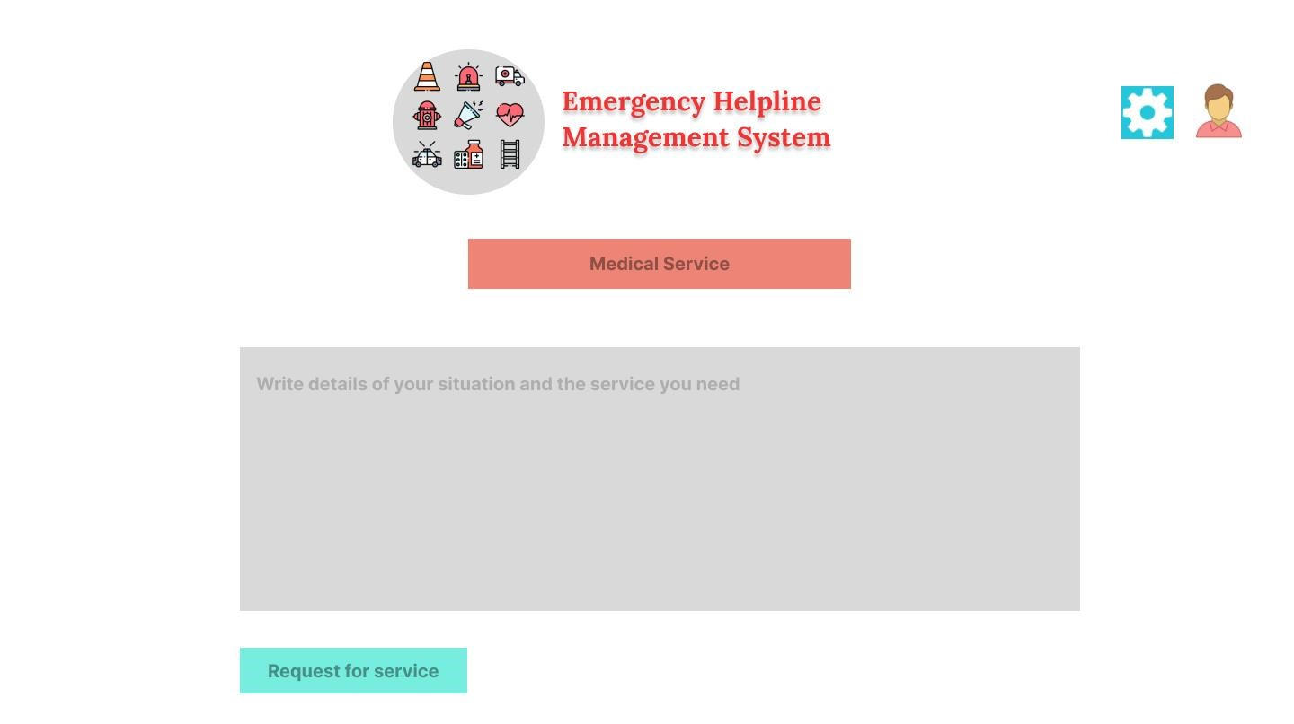

## Rescue Service

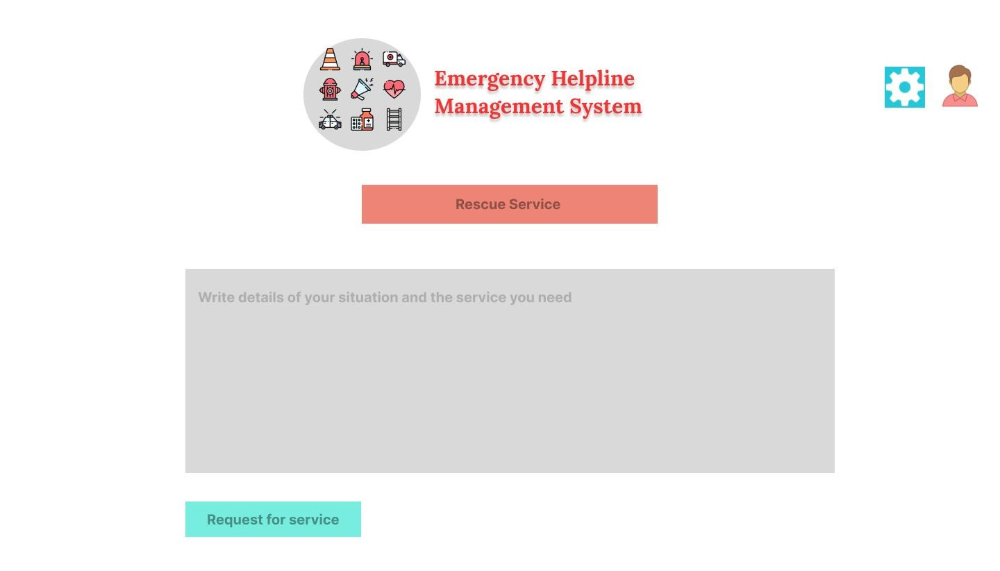

## Edit Profile

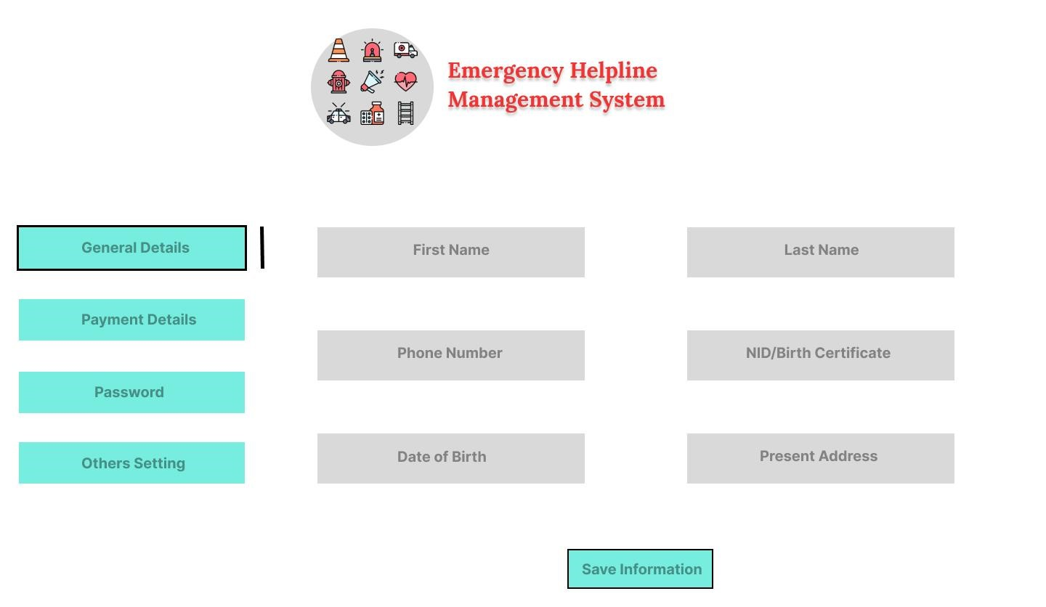

## Forgot Password

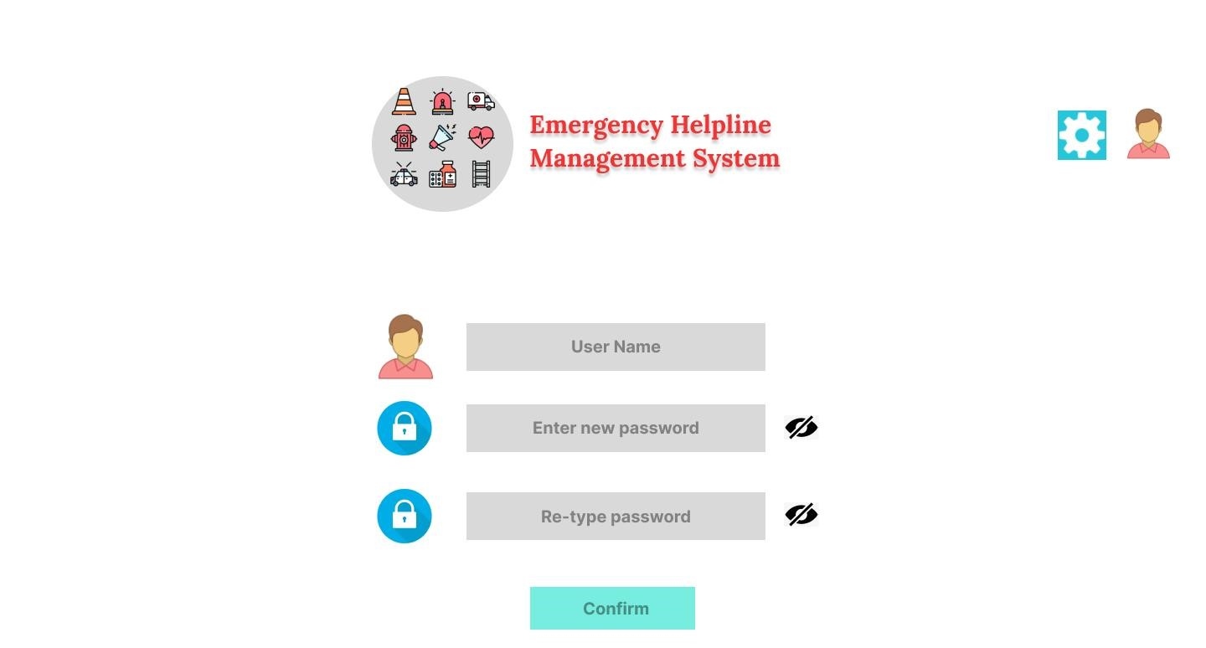

## Feedback

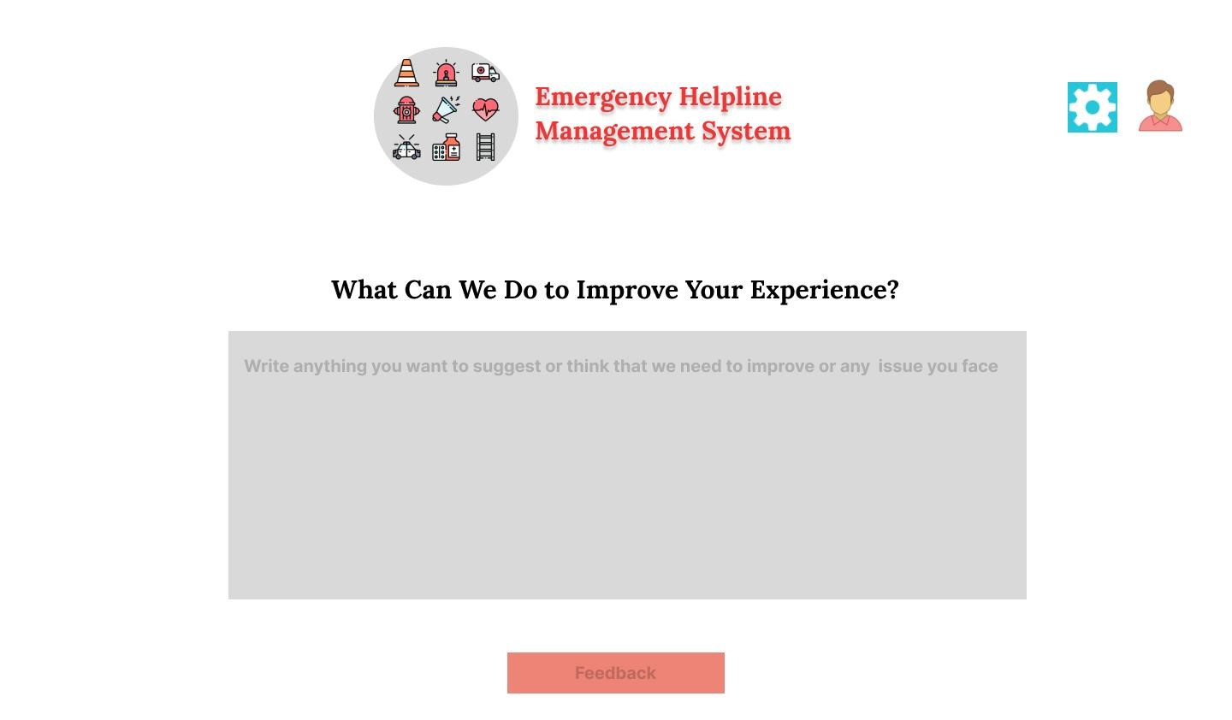

## Payment

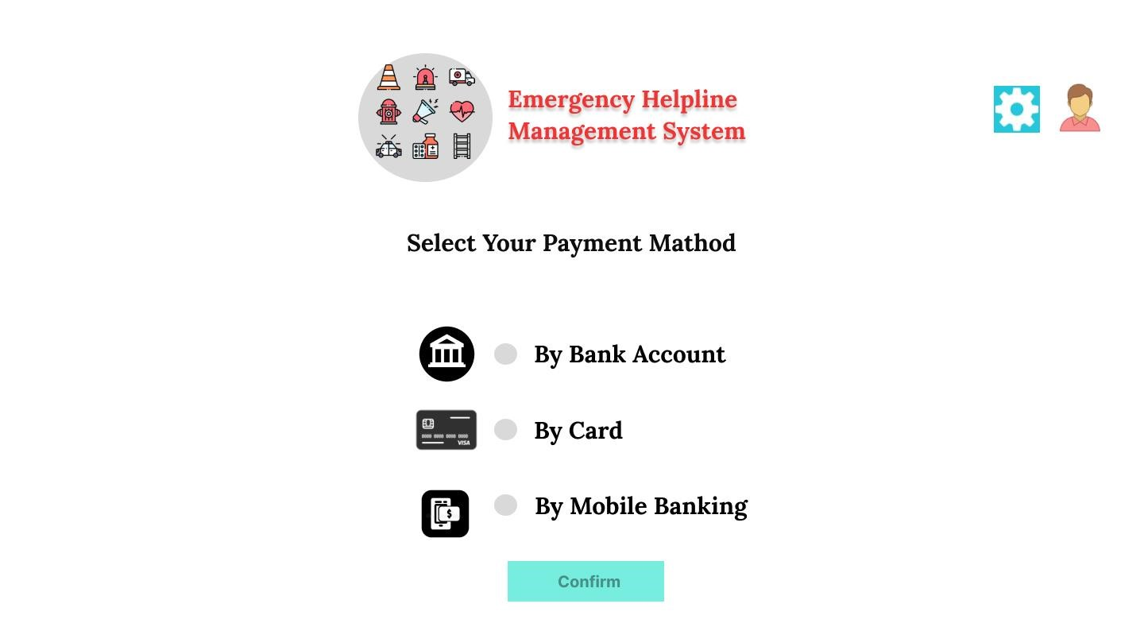

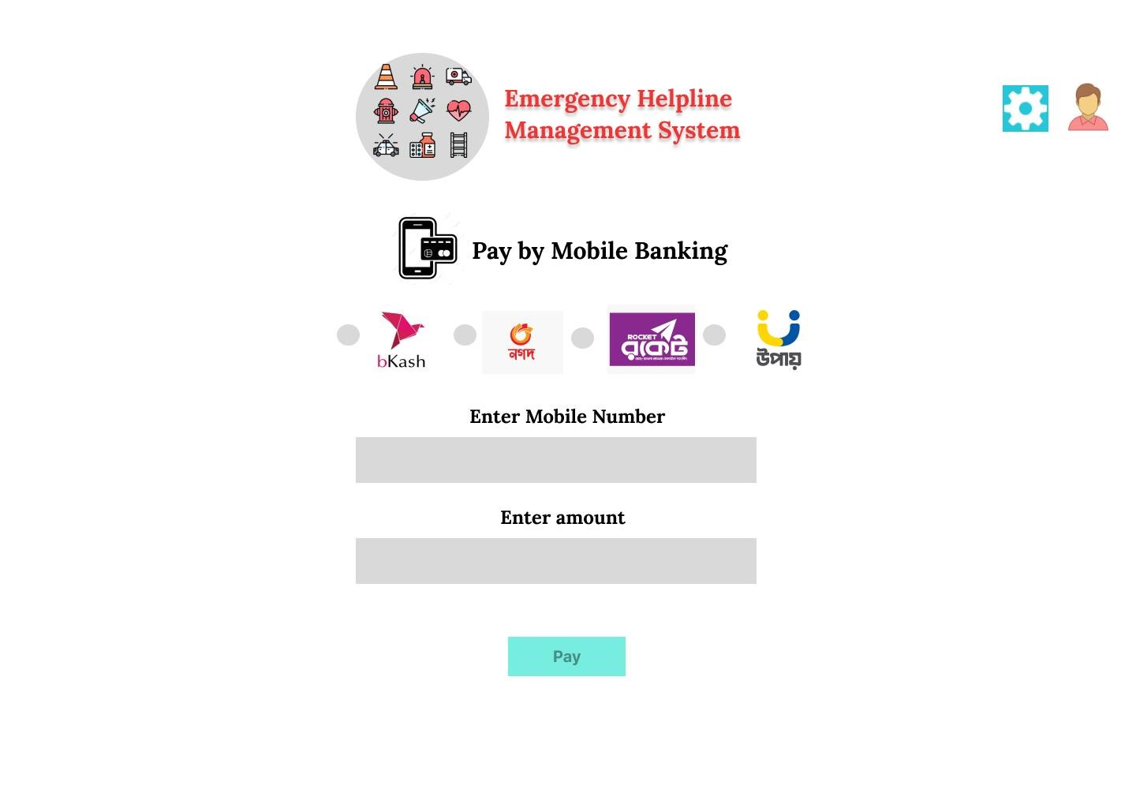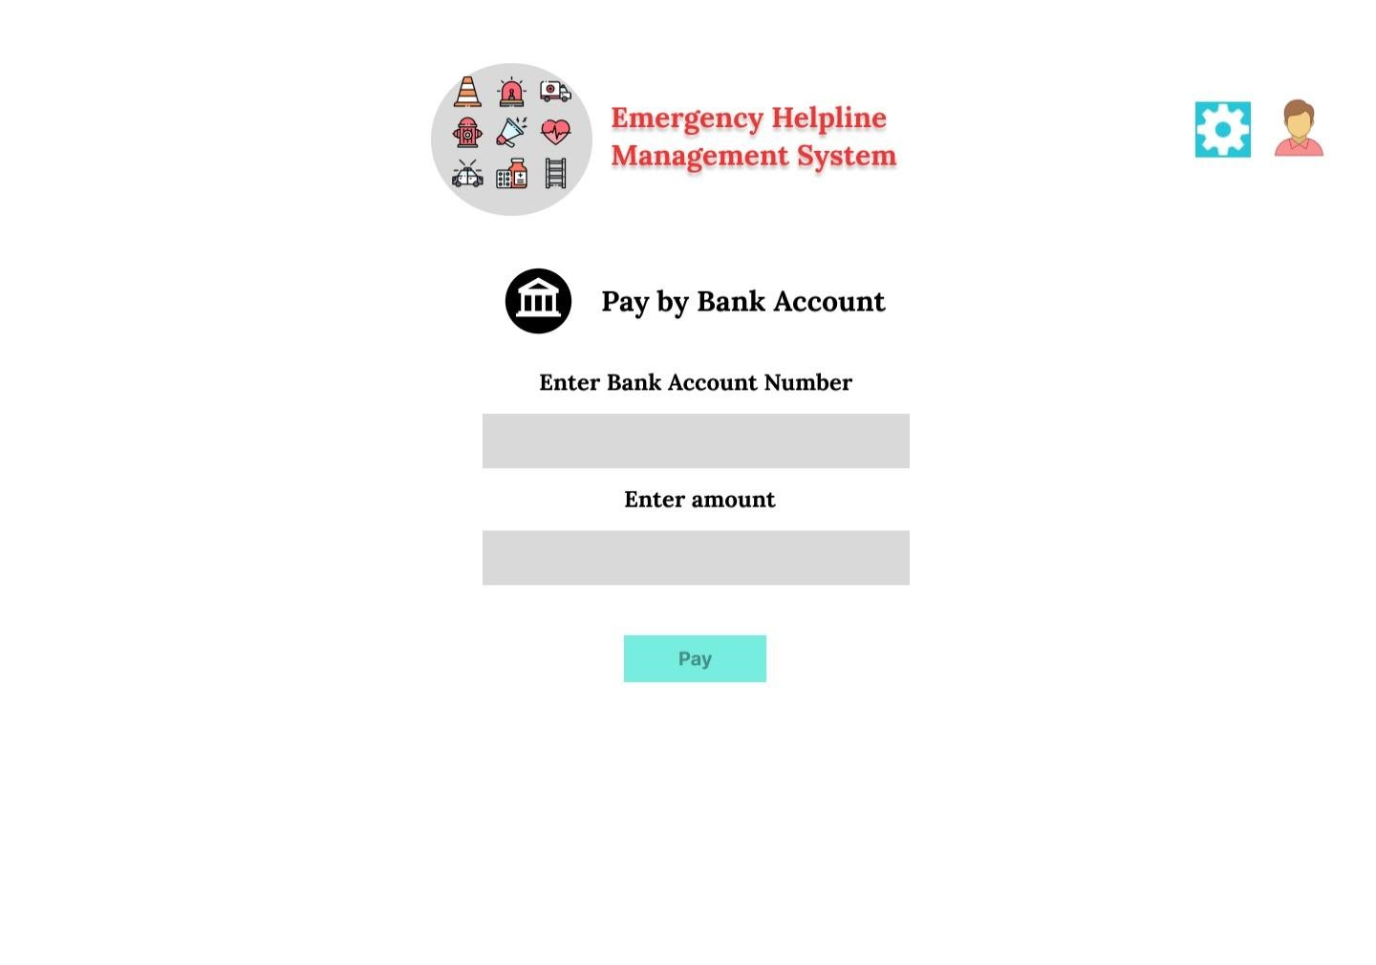

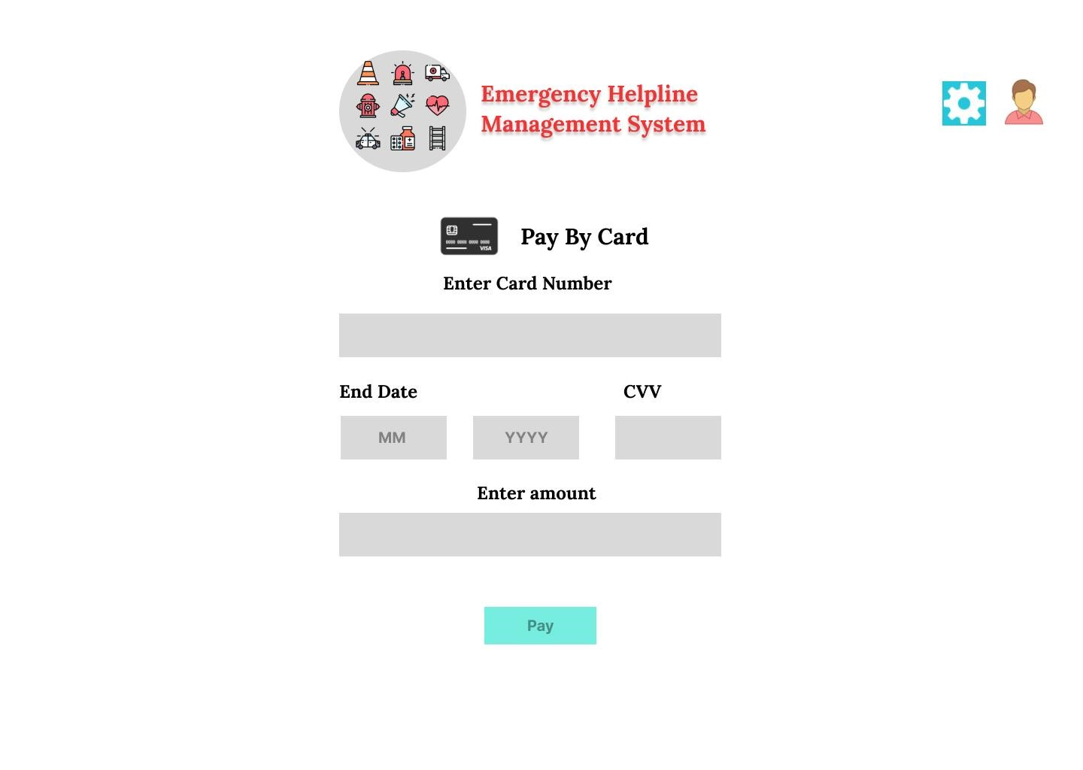

## Pending Reports (Admin)

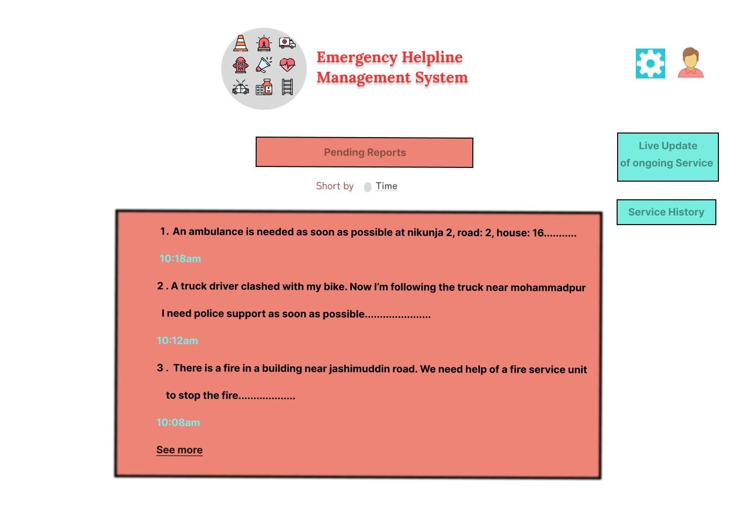

## Service History(Admin)

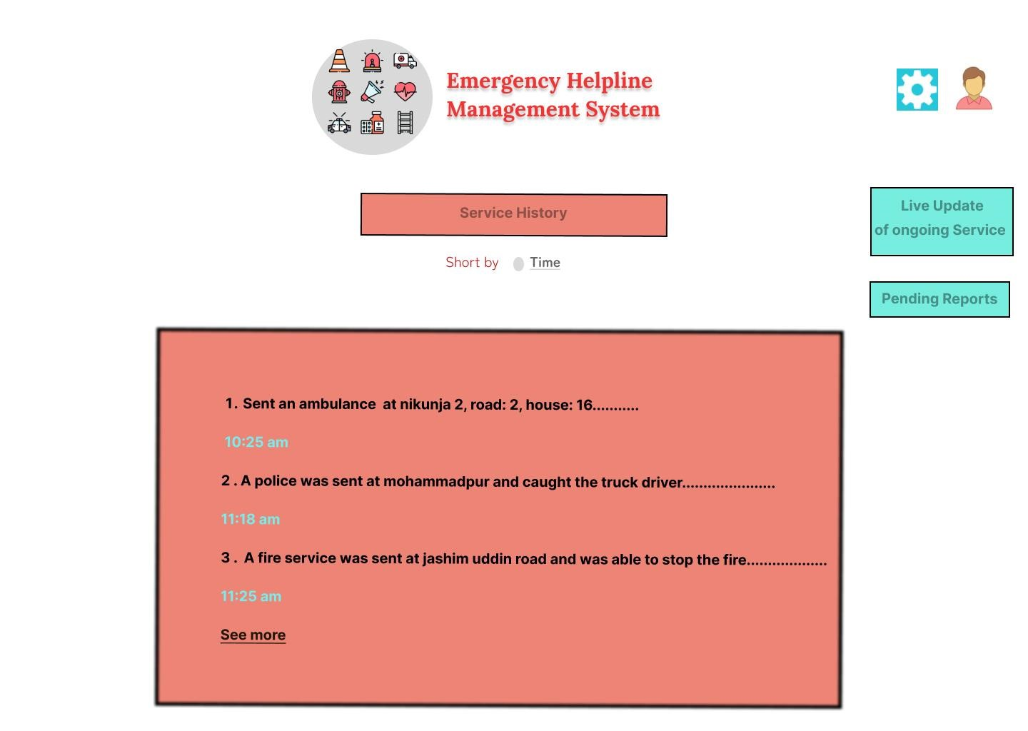

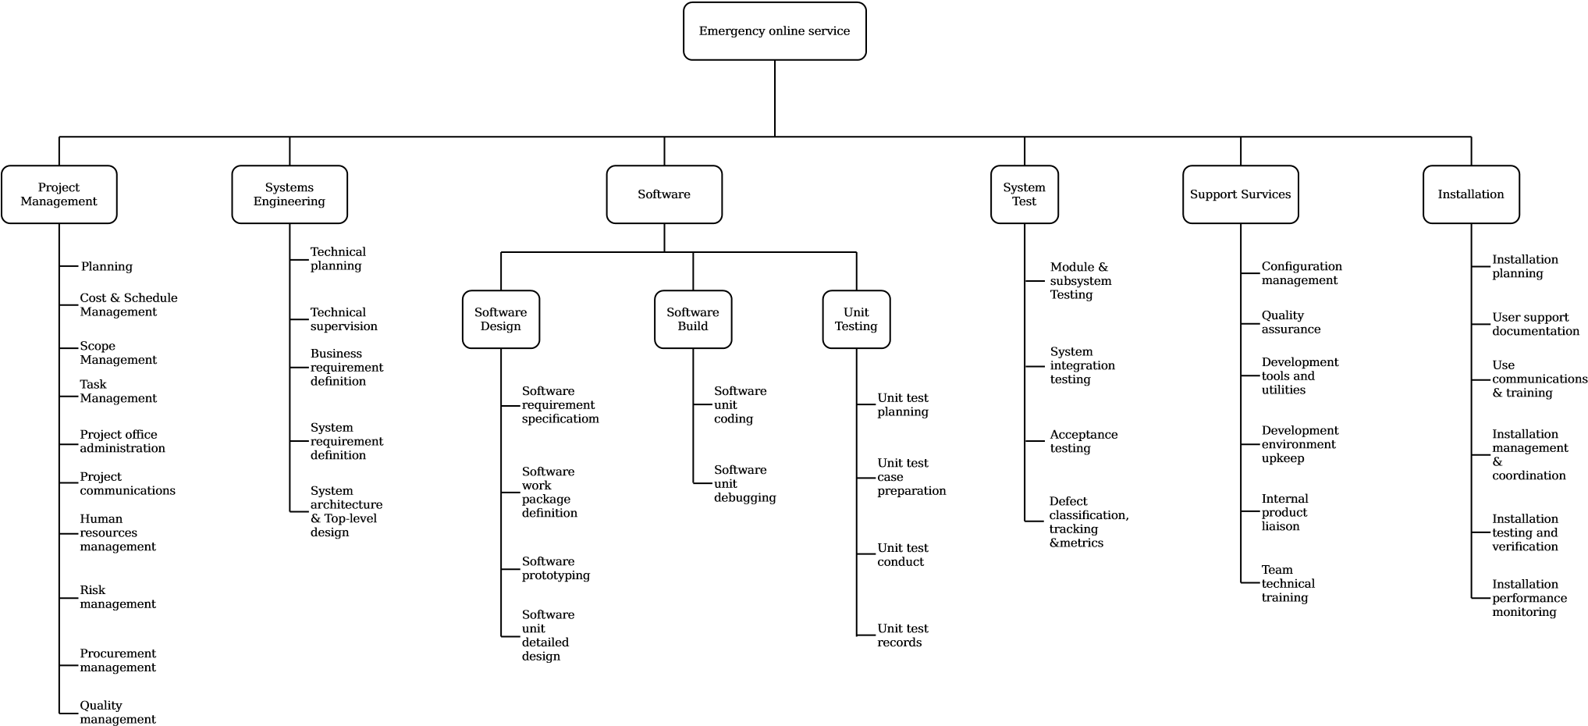

PM = 2.4 × (8500 ÷ 1000)1.05= 22.70

DM = 2.5 × 𝑃𝑀𝑇= 2.5 × 22.700.38= 8.23

𝑃𝑀

ST =

𝐷𝑀

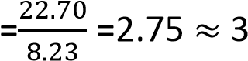

Weeks = 8 * 4 = 24

**EVA**

|  |  |  |
| --- | --- | --- |
| Task | Planned Effort | Actual Effort |
| 1 | 12.0 | 12.5 |
| 2 | 15.0 | 11.0 |
| 3 | 13.0 | 17.0 |
| 4 | 8.0 | 9.5 |
| 5 | 9.5 | 9.0 |
| 6 | 18.0 | 19.0 |
| 7 | 10.0 | 10.0 |
| 8 | 4.0 | 4.5 |
| 9 | 12.0 | 10.0 |
| 10 | 6.0 | 6.5 |
|  |  |  |

BAC = 160.00

SPI = BCWP/ BCWS = 107.5/ 156.5 = 0.69

SV = BCWP - BCWS = 107.5 - 156.5 = -49 person-day

CPI = BCWP/ ACWP = 107.5/109 =0.99

CV = BCWP – ACWP = -1.5 person-day

% Schedule for completion = BCWS/ BAC = 156.5/ 160

### = 0.98%

[% of work scheduled to be done at this time]

% complete = BCWP/ BAC = 107.50/ 160 = 0.67%

### [% of work completed at this time]

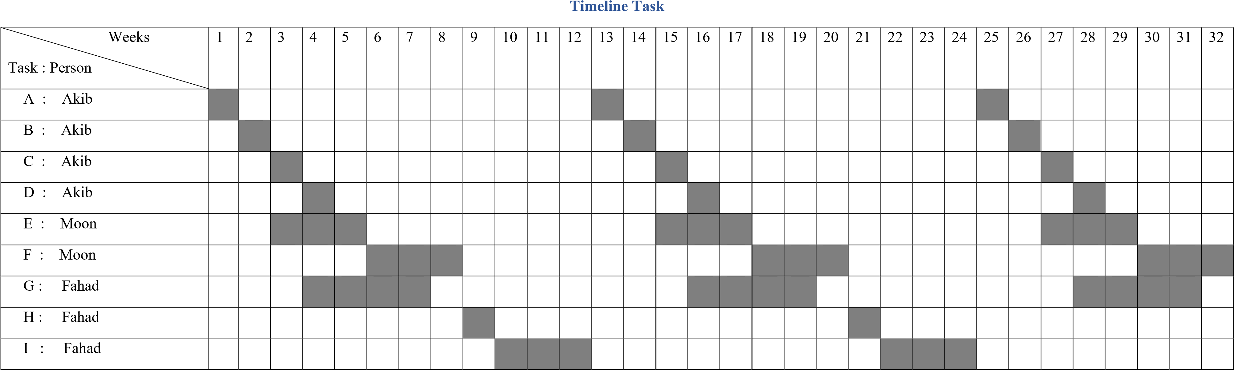

Activity key: A : Overall design F : Code module 3

1. : Specify module 1 G : Code module 2
2. : Specify module 2 H : Integration testing
3. : Specify module 3 I : System testing
4. : Code module 1

Lab10:

|  |  |  |  |
| --- | --- | --- | --- |
| **Risks** | **Category** | **Probability** | **Impact** |
| Size estimate may be significantly low | PS | 40% | 2 |
| Larger number of users than planned | PS | 40% | 3 |
| Less reuse than planned | PS | 50% | 2 |
| End-users resist system | BU | 40% | 3 |
| Delivery deadline will be tightened | BU | 30% | 2 |
| Funding will be lost | CU | 60% | 1 |
| Customer will change requirement | PS | 30% | 2 |
| Technology will not meet expectations | TE | 30% | 1 |
| Lack of training on tools | DE | 60% | 3 |
| Staff inexperienced | ST | 30% | 2 |
| Staff turnover will be high | ST | 30% | 2 |
| Schedule Risk | PS | 30% | 1 |
| Technical Risk | DE | 50% | 2 |
| Purchasing Risk | CU | 40% | 3 |
| User Engagement | CU | 20% | 1 |

**Impact values:**

* 1. **Catastrophic**
  2. **Critical**
  3. **Marginal**

#### 4. Negligible Timeline Chart

